Certificate of Completion

Is addressed to
Ariane Panetier

For completing the ……

 | 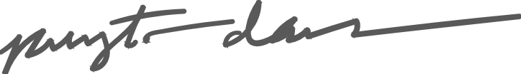 |  | June 4, 20XX
 | Payton Davis, Teacher |  | Date

