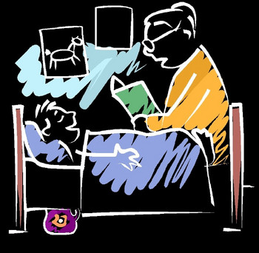
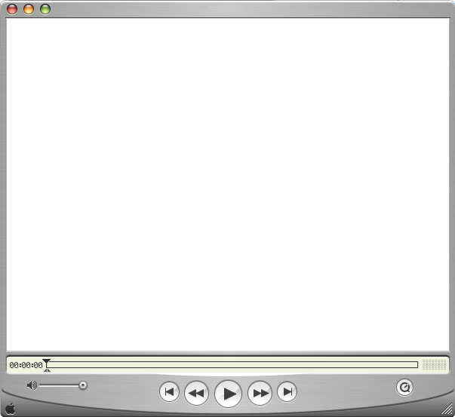
Digital storytelling storyboard templates

The templates in this packet have been adapted from traditional storyboard materials for use with digital storytelling projects. The templates are in two forms: 1 screen per page and 2 screens per page. They have been created with Word tables and are very adaptable. Feel free to reconfigure as needed. If you have the PDF version and need the Word version (or vice versa), please let me know.

Jason
www.jasonohler.com/storytelling | jason.ohler@uas.alaska.edu

Page: | Date: | Project name: | Author:
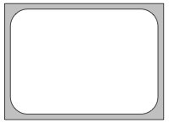  Here you do a quick sketch of what will appear at this point in your digital story… you can also paste a graphic or photo here…do whatever works to remind you of what ‘s going on … |  | Frame/event description | Media list
 |  | Here you describe:  - what will appear on the screen (picture, clip, graphic or other kind of visual)  - what listeners will hear (music, narrative, sounds)  - your director’s comments about what you are trying to achieve and communicate… | Here you list the specifics of every piece of media you will need; this will help you gather materials before beginning story construction; it also serves as a “works cited list” for copyright purposes…  - Music, songs, sounds, voice recordings  - Pictures, graphics, diagrams  - Video clip  - Text, titles, transitions
narration:

Here you write out or describe the narrative…
narration:

Page: | Date: | Project name: | Author:
 |  | Frame description | Media list and description
narration:

narration:

Page: | Date: | Project name: | Author:
 |  | Frame description
narration:

media list:

