Storyboard Template

This template document contains some sample storyboard templates. Choose whichever one suits your needs, and of course you may amend the template as you see fit to accommodate your project.

The idea with storyboards is to block out your video or multimedia project before you go to the expense of creating any of the elements. The storyboard review and approval stage is one of the stages of pre-production that allows all stakeholders to visualize the final project, to an extent. It provides an opportunity for discussion, and helps you determine your final budget. Storyboards also help you save time and money when you put the elements together because you know what shots can be grouped together, taken at the same time, or with the same resources.

Depending on your organization, storyboards can be very informal – just scribbles and stick figures, or more formal – good looking graphics. Personally, I don’t want to spend a lot of time or money on storyboards when those resources could be better used during actual production.
Video Storyboard

TITLE of Project: ________________________________________

SUBJECT: _________________________________ PAGE: ____

VIDEO | AUDIO
Rough sketch of the shot. Stick figures acceptable. | Narration, voiceover script, dialogue, sound effects, music, etc.

Sample

Screen Title: __________________________________________________ Date: 15/05/2006 10:03 AM
800 x 600 Screen 8 of 15

Links from:

Links to:

Navigation: Graphics:  Animation:  Audio:  Video:  Functionality:  Interactivity:  Hyperlinks: | Screen Description
Screen Title: __________________________________________________ Date: 15/05/2006 10:03 AM
800 x 600 Screen 9 of 15

Links from:

Links to:

Navigation: Graphics:  Animation:  Audio:  Video:  Functionality:  Interactivity:  Hyperlinks: | Screen Description
Screen Title: __________________________________________________ Date: 15/05/2006 10:03 AM
800 x 600 Screen 10 of 15

Links from:

Links to:

Navigation: Graphics:  Animation:  Audio:  Video:  Functionality:  Interactivity:  Hyperlinks: | Screen Description
Screen Title: __________________________________________________ Date: 15/05/2006 10:03 AM
800 x 600 Screen 11 of 15

Links from:

Links to:

Navigation: Graphics:  Animation:  Audio:  Video:  Functionality:  Interactivity:  Hyperlinks: | Screen Description
Screen Title: __________________________________________________ Date: 15/05/2006 10:03 AM
800 x 600 Screen 12 of 15

Links from:

Links to:

Navigation: Graphics:  Animation:  Audio:  Video:  Functionality:  Interactivity:  Hyperlinks: | Screen Description
Screen Title: __________________________________________________ Date: 15/05/2006 10:03 AM
800 x 600 Screen 13 of 15

Links from:

Links to:

Navigation: Graphics:  Animation:  Audio:  Video:  Functionality:  Interactivity:  Hyperlinks: | Screen Description
(Select all on previous page, highlight this line, copy to this page overwriting this line)
Multimedia Storyboard
.............................................................................................
project:
date:
.............................................................................................
screen: ___ of ___  links from screens:  links to screens: | screen description:
.............................................................................................
functionality/interactivity:
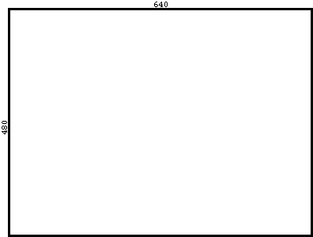
background:  color schemes:  text attributes: | audio:  video:  stills:

