Name_________________________________ Date__________ Period______

Lab: Evidence Of Evolution

BACKGROUND: Much evidence has been found to indicate that living things have evolved or changed gradually during their natural history. The study of fossils as well as work in embryology, biochemistry, and comparative anatomy provides evidence for evolution.

OBJECTIVES: In this lab you will learn about homologous, analogous, and vestigial structures and their significance in evolution theory.

MATERIALS: Colored pencils and worksheet.

PROCEDURES AND OBSERVATIONS:

PART I. HOMOLOGOUS STRUCTURES (definition): ________________________________
__________________________________________________________________________

1. Carefully examine the drawings of the bones shown in Figure 1 on the next page. Look for
similarities among the various animals.
a. Color each part of the human arm a different color. (Note: All bones of the wrist should be a single color; all the bones of the hand should be a different single color, etc.) Then color the corresponding bone in each of the other animals the same color as the human bone.

b. Describe the function of each structure below:

ANIMAL | FUNCTION OF STRUCTURE
HUMAN
WHALE
CAT
BAT
BIRD
CROCODILE

c. Are the bones arranged in a similar way in each animal? ________________________

These structures are formed in similar ways during embryonic development and share like arrangements; however they have somewhat different forms and functions. They are called homologous structures. Choose a color for each bone on the human forelimb and color the corresponding bone in the other organisms the same color.
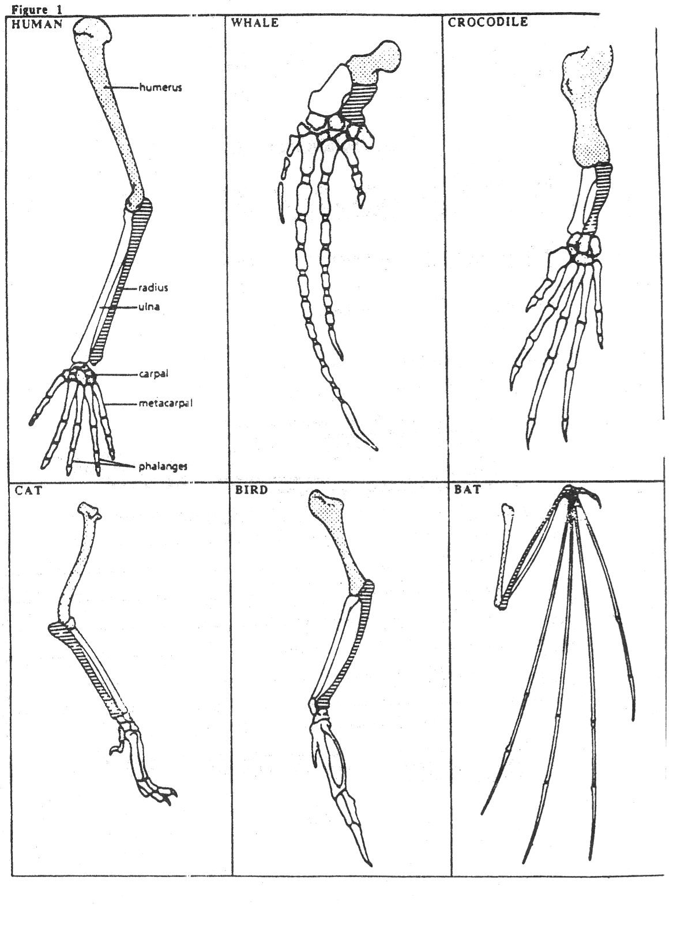

humerus
humerus

Radius

Ulna

Some apparently unrelated animals have organs with similar functions, yet are very different in structure and form. These structures are called analogous structures.

PART II. ANALOGOUS STRUCTURES
(definition): ________________________________________________________________
__________________________________________________________________________

1. Examine the butterfly wing and the bird wing shown in Figure 2.
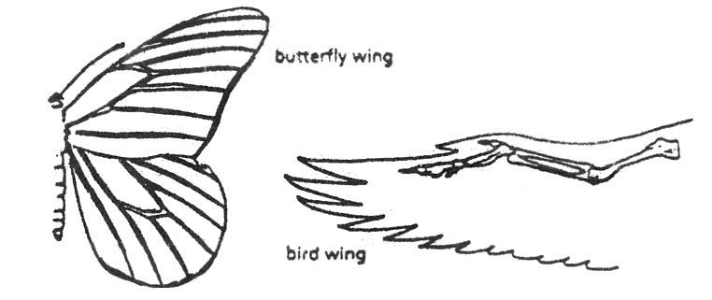

Figure 2.
a. What function do these structures share? ____________________________
b. How are these structures different? ________________________________
_______________________________________________________________

c. Do birds and insects share any structural (elements inside the wing) similarities
that would suggest they are closely related taxonomically?
_________________________________________________________________

PART III. VESTIGIAL STRUCTURES
(definition): ________________________________________________________________
__________________________________________________________________________

Gradual changes have occurred through time that have in some cases reduced or removed the function of some body structures and organs. The penguin's wings and the leg bones of snakes are examples of this phenomenon.

1. The cavefish and minnow shown in Figure 3 are related. Both the cavefish and the minnow have eyes, but the cavefish is blind.
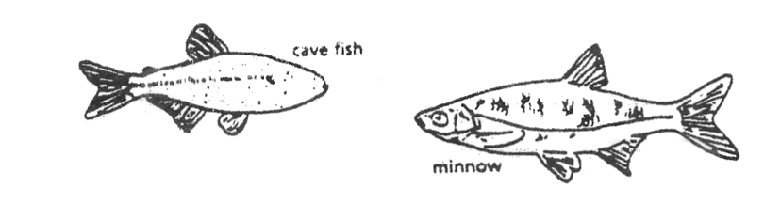

Figure 3.

a. Explain why eyesight is not an important adaptation to life in a cave.

____________________________________________________________________
b. What do you think has become the most important adaptation of the cave fish (think
about senses)? (explain your answer)
____________________________________________________________________

c. What about the internal structure of the cavefish and minnow suggest common ancestry?

____________________________________________________________________

____________________________________________________________________

2. Read the list of human vestigial structures shown in Table 1.

c. Suggest a possible function for each structure and explain why it became vestigial. Record your answers in the table.

Table 1.

STRUCTURE | POSSIBLE FUNCTION | WHY VESTIGIAL?
appendix (digests leaves in koala bears)
coccyx (tail bones)
muscles that move ears
muscles that make hair stand up
little toe
wisdom teeth

ANALYSIS AND INTERPRETATIONS

1. Explain why the homologous structures in Part I are evidence of evolutionary relationships.
____________________________________________________________________
____________________________________________________________________
____________________________________________________________________
2. Explain the evolutionary relationship between the fin of a fish and the flipper of a whale.
____________________________________________________________________
____________________________________________________________________
____________________________________________________________________
3. List two structures (not from Table 1) that you think are vestigial and explain why.
1. ___________________________________________________________________
__________________________________________________________________
2. ___________________________________________________________________
__________________________________________________________________
4. Re-define the three different types of evidence for evolution that you have studied in this lab in your own words.
1. HOMOLOGOUS STRUCTURES - __________________________________________
____________________________________________________________________
____________________________________________________________________
2. ANALOGOUS STRUCTURES - ___________________________________________
____________________________________________________________________
____________________________________________________________________
3. VESTIGIAL ORGANS - ________________________________________________
____________________________________________________________________
____________________________________________________________________

